Turning a Christmas Ornament
Combine these 24k gold fittings, and your woodturned body to make a truly unique Christmas ornament that will be treasured for years to come. This project can be turned on a standard pen mandrel, with standard woodturning tools.

PREPARING THE BLANK
- Drill a 7mm hole through a 2″ x 2″ x 2” blank. Glue the long brass tube into the blank with CA glue or epoxy. Use a Barrel Trimmer to trim both ends of the blank to ensure a proper fit when assembled. Mount the blank onto a pen mandrel. True the ends of the blank using the long point of a 1/2″ skew chisel laying flat on its side.
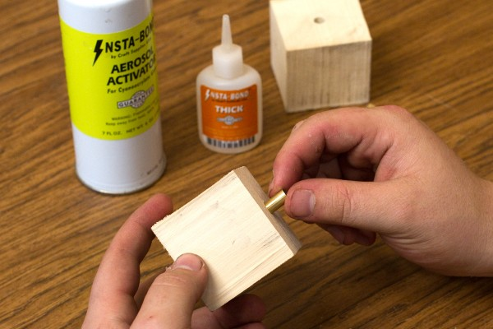

TURNING THE ORNAMENT
- Turn the blank down to round creating a taper from 1-1/2″ at one end to 3/4″ diameter on the other. Mark a line 5/8″ in from each end of the blank. This indicates where the underside of the tiered rings will be.
- Using a parting tool, make a part at each pencil mark down to the desired diameter. Use a spindle gouge to shape the ornament beginning with the small end of the tree.
Hint: If you have a hard time turning the underside of the ornament, lay the skew chisel on its side and use the long point to make the cut. This technique is easy to do and will reduce the likelihood of a catch.
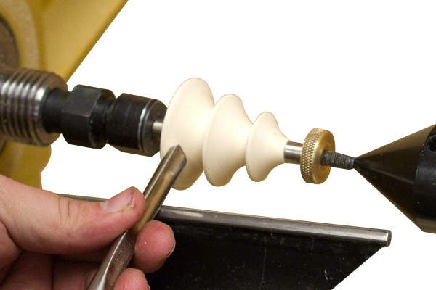
- Finish shaping the ornament as desired.

SANDING AND SEALING THE ORNAMENT
- Sand the ornament through 320 grit using sandpaper.
- Coat the entire ornament with Deft Clear Wood Finish. Wipe off the excess and let dry. When dry, use steel wool to sand away the Deft down to the bare wood. The sealed surface helps to produce a more consistent color when applied.
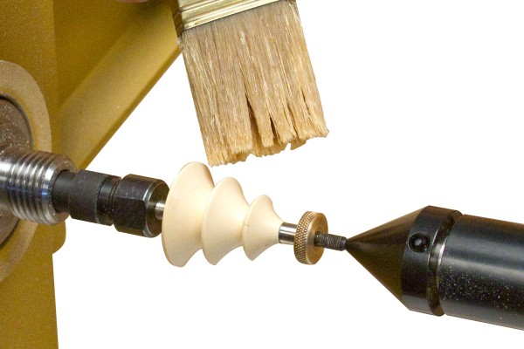

COLORING AND FINISHING THE ORNAMENT
- With the lathe running about 500 rpm, color the ornament with the Tombow marker tip held in a trailing position. Once coloring is complete, use the long point of the skew chisel laying flat on its side to cut a fine detail line to separate the colored areas.
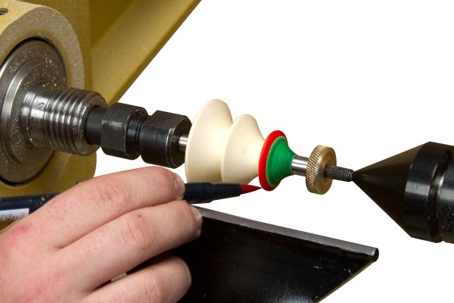
- Apply your choice of lacquer based finish to seal the color. We recommend Mylands Friction Polish or Masters Magic Spray Lacquer. Remove the ornament from the mandrel and assemble.
Hint: To prevent the color from bleeding, hold the finishing rag in a stationary position, do not move side to side.
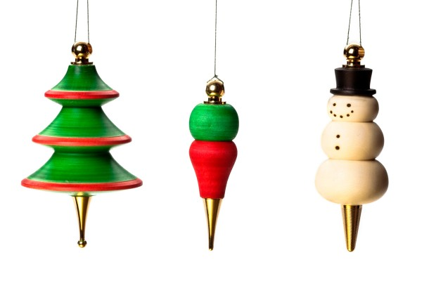

SUPPLIES USED:
- Roughing Gouge
- Spindle Gouge
- Deft Clear Wood Finish
- Tombow Marker
- Spray Lacquer

