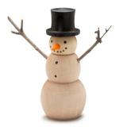

Turning a Snowman Box
Turn a festive Snowman Box that is sure to be this year’s favorite decoration. This woodturning project requires only a few tools and a little creativity.

BLANK PREPARATION
- Select a blank that is 3″ x 3″ x 4-1/2″. Use a center finder and mark the center on each end of the blank. Mount the blank on the lathe between centers using a cone center and drive center.

TURNING THE BLANK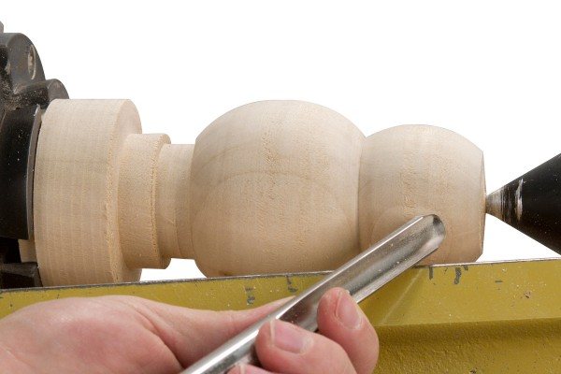
- With a roughing gouge turn the blank to round. Turn a tenon on one end of the blank to fit in the jaws of your chuck. ( Turn the tenon to match the profile of your jaws for a secure hold.)
- Mount the blank in a chuck using the tenon. Support the opposite end with a revolving center. Using a spindle gouge turn the snowman body to shape as per the Snowman Diagram dimensions.
- Remove the revolving center and use a 7/8″ forstner bit mounted in a drill chuck and drill a hole in the blank 2-1/2″ deep.
- Using a parting tool, part off the blank leaving 1/8″ of excess material on the base of the snowman. Leave the remaining blank in the chuck. Turn a 1/2″ long tenon on the remaining blank to fit the drilled hole in the snowman. Check for fit frequently.

REVERSE CHUCKING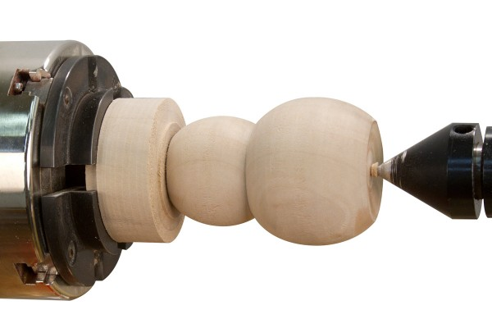
- Mount the drilled end of the snowman on the tenon. Use a revolving center in the tailstock to support the blank. Turn a flat or slightly concave base on the snowman. Leave a small tenon of waste material to support the blank while sanding and finishing.

SANDING AND FINISHING
- Sand the snowman through 320 grit or higher. To add a little creativity to your snowman, use white liming wax or paint to color the snowman body white.
- Remove the snowman from the lathe. Use a chisel or handsaw to remove the remaining waste material from the base of the snowman. Sand and finish the exposed ends.

TURNING THE HEAD AND HAT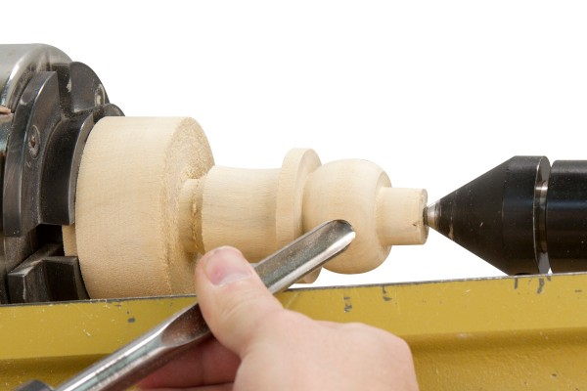
- Select a blank that is 3″ x 3″ x 3-1/2″. Use a center finder and mark the center on each end of the blank. Mount the blank on the lathe between centers using a cone center and drive center.
- With a roughing gouge turn the blank to round. Turn a tenon on one end of the blank to fit in the jaws of your chuck. ( Turn the tenon to match the profile of your jaws for a secure hold.)
- Using a spindle gouge turn the snowman hat/head to the diagram dimensions.

SANDING AND FINISHING
- Sand the snowman hat/head through 320 grit.
- Finish the snowman hat/head with your choice of finish. We recommend using Deft Clear Wood Finish to seal and finish the blank. Apply the Deft to the snowman hat/head with the lathe stopped using a brush or rag. Apply liberally to the blank and wipe off the excess. Once dry, use a paste wax and steel wool while the lathe is running to smooth the deft, leaving a sealed and streak-free surface.
- Match the head to the body and use white liming wax or paint to color the snowman head white. To make an authentic snowman, use a tombow marker to color the hat black. Hint: You could also use paint or black shoe polish if needed.
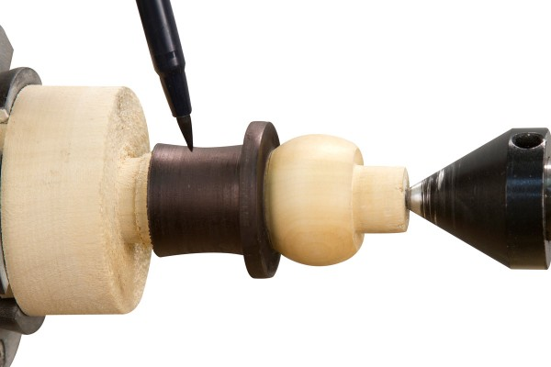
- Use a Parting tool or long point of a skew and part the snowman hat/head from the remaining blank. Sand and finish the top of the hat. Use a woodburner or black marker and draw a face and a few buttons on the snowman.
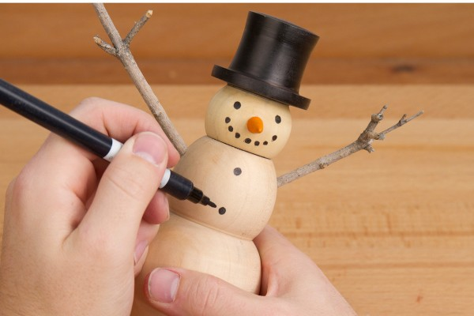

TURNING THE NOSE (OPTIONAL)
- Drill a small nose hole in the face of the snowman. Turn a small nose to fit in the drilled hole. Use CA glue and glue the nose into the hole.

MAKING THE ARMS (OPTIONAL
- Drill two arm holes in the snowman that will fit a couple small twigs. Use CA Glue or Epoxy to glue the twigs into the arm holes.
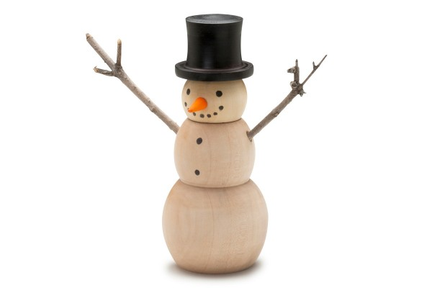

SUPPLIES USED:
- Roughing Gouge
- Spindle Gouge
- Deft Clear Wood Finish
- Tombow Marker
- Spray Lacquer

